**Data Analysis**

Note : The scripts are placed in separate folder named as Scripts – Kinldy refer to it.

**Creating hive lookup tables and loading data into it**

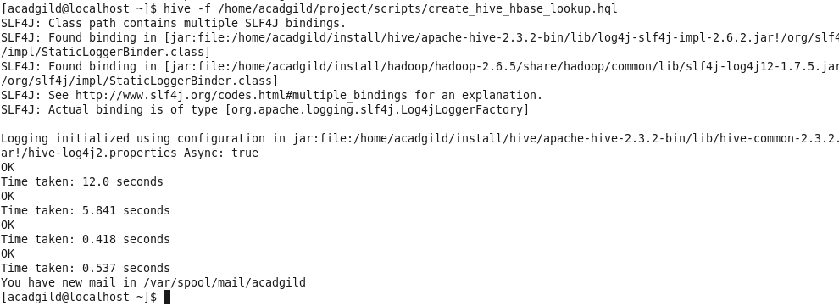

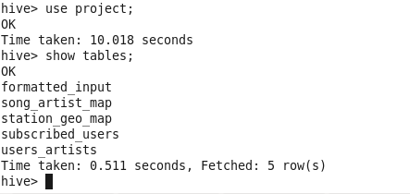

[acadgild@localhost ~]$ hive -f /home/acadgild/project/scripts/create\_hive\_hbase\_lookup.hql  
SLF4J: Class path contains multiple SLF4J bindings.  
SLF4J: Found binding in [jar:file:/home/acadgild/install/hive/apache-hive-2.3.2-bin/lib/log4j-slf4j-impl-2.6.2.jar!/org/slf4j/impl/StaticLoggerBinder.class]  
SLF4J: Found binding in [jar:file:/home/acadgild/install/hadoop/hadoop-2.6.5/share/hadoop/common/lib/slf4j-log4j12-1.7.5.jar!/org/slf4j/impl/StaticLoggerBinder.class]  
SLF4J: See [http://www.slf4j.org/codes.html#multiple\_bindings](http://www.slf4j.org/codes.html" \l "multiple_bindings" \t "_blank) for an explanation.  
SLF4J: Actual binding is of type [org.apache.logging.slf4j.Log4jLoggerFactory]  
  
Logging initialized using configuration in jar:file:/home/acadgild/install/hive/apache-hive-2.3.2-bin/lib/hive-common-2.3.2.jar!/hive-log4j2.properties Async: true  
OK  
Time taken: 12.0 seconds  
OK  
Time taken: 5.841 seconds  
OK  
Time taken: 0.418 seconds  
OK  
Time taken: 0.537 seconds  
You have new mail in /var/spool/mail/acadgild

**Data Analysis**

Note : all the data analysis script are placed in scripts folder- kindly refer to it.

**